1. Summarize chapters 3 and 4 (3. PROGRAM STRUCTURE, 4. BASIC SYNTAX ) in the text book.

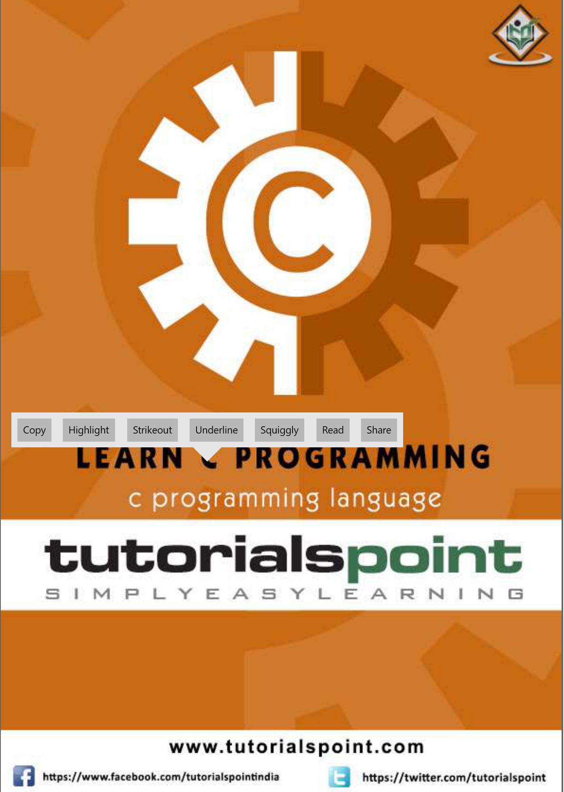

1. Install the Microsoft Visual Studio Community 2019 based on the C lan_L_02_Fin.pptx file.
2. Submit your own program based on all the sample codes in each chapter (1,2,3, and 4) provided in the textbook. And take a picture of the solutions and attach the picture to the assignment file.